Setting up Supabase and Adding Data

This document walks you through the whole process of setting up a Supabase account, project instance, and adding data to your tables. The whole process should take about ten minutes and should be done BEFORE the sessions begin. Once you have done this, you’re good to go for all three sessions. If you’re dipping in to just one or two sessions, you’ll still need to follow this process to set up the underlying database correctly.

- Create a free Supabase account at https://supabase.com. .
- Once you’ve set up your account, you’ll need to create a project, as below.
  - I recommend selecting the region as West Europe, but it’s your choice!
  - You’ll also need to set a database password - make sure you save this and don’t lose it.
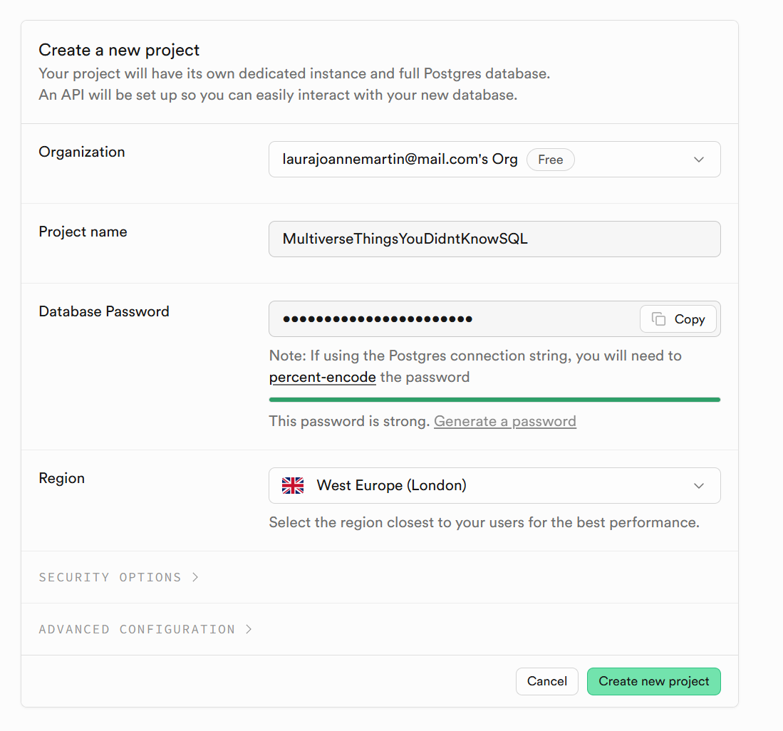

- Next, you’ll need to add the datasets as three tables. Inside your project, select the side bar and select ‘Table editor’, then ‘Create a Table’.

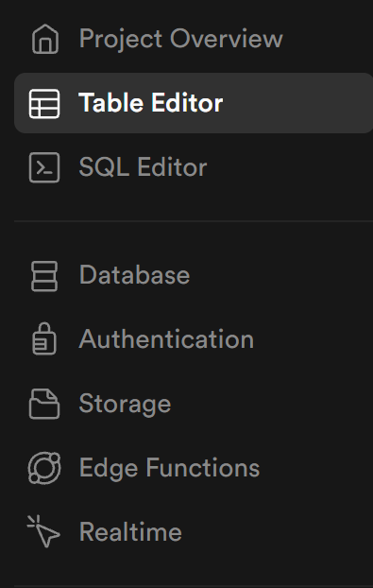

- Add the Customers CSV file by importing the data from CSV.
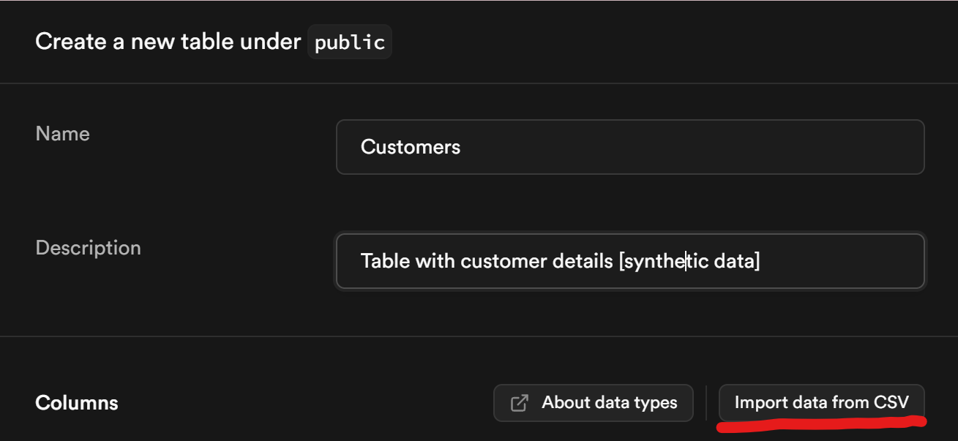
- Wait for the data to upload; this is a large synthetic dataset, so it may take a while.
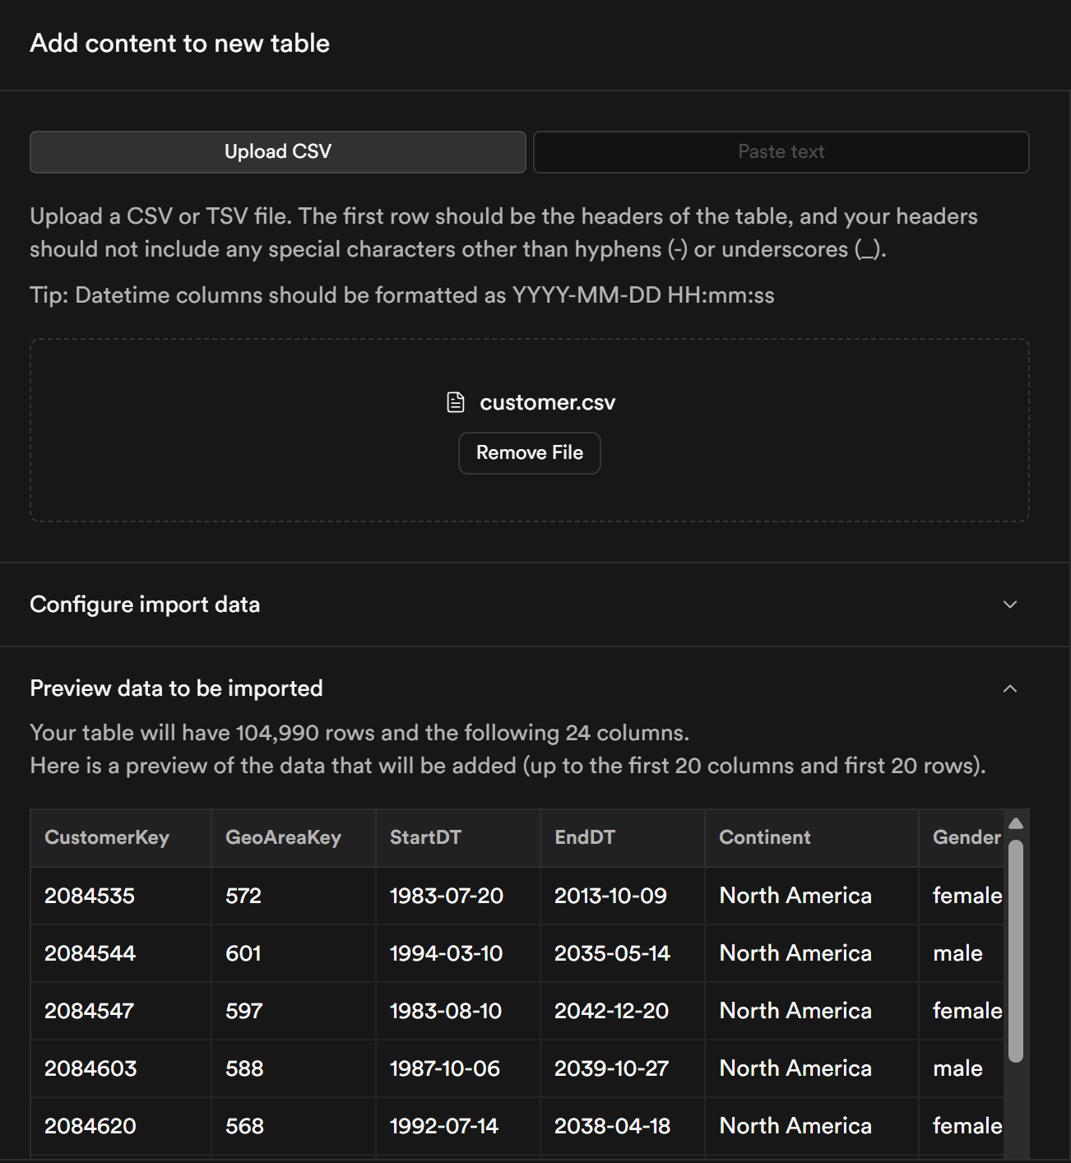

- Check the data types on each column; ensure that numbers are stored as integers, and that dates are stored as dates. Select the CustomerKey column as the primary key column.
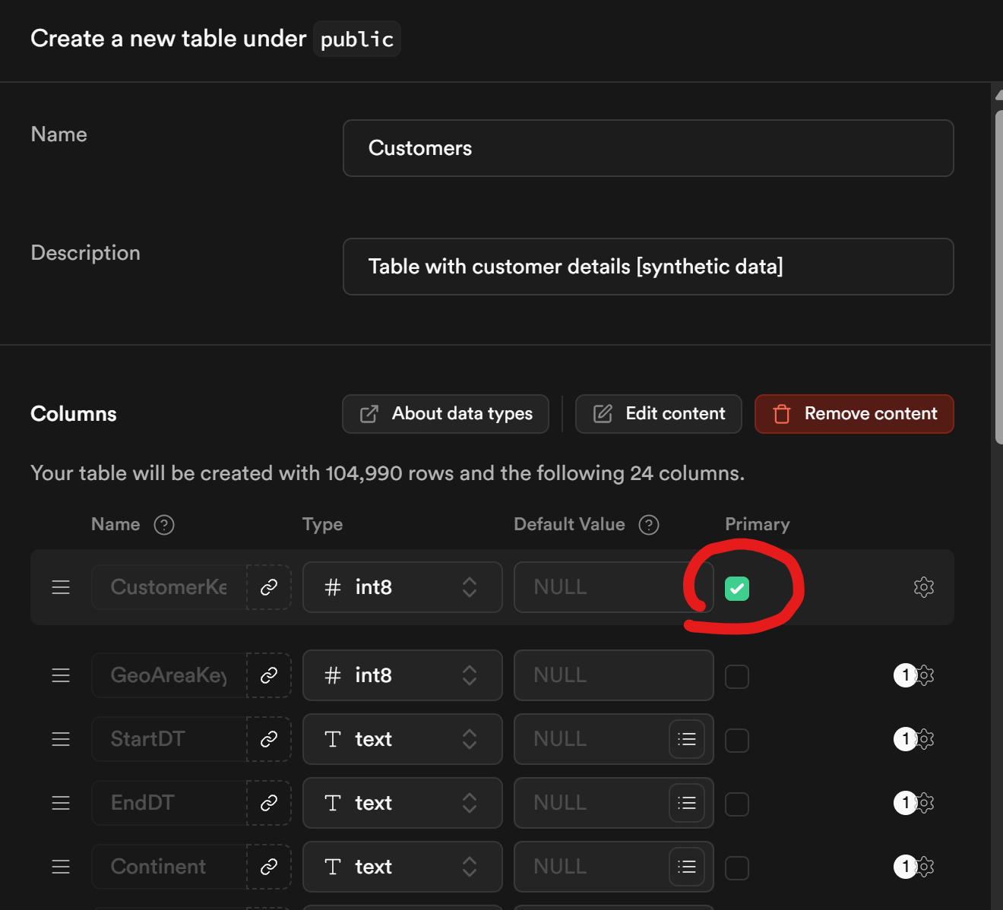

- Follow the same process for the ‘Products’ table, remembering to check data types and select the ProductKey as a primary key.

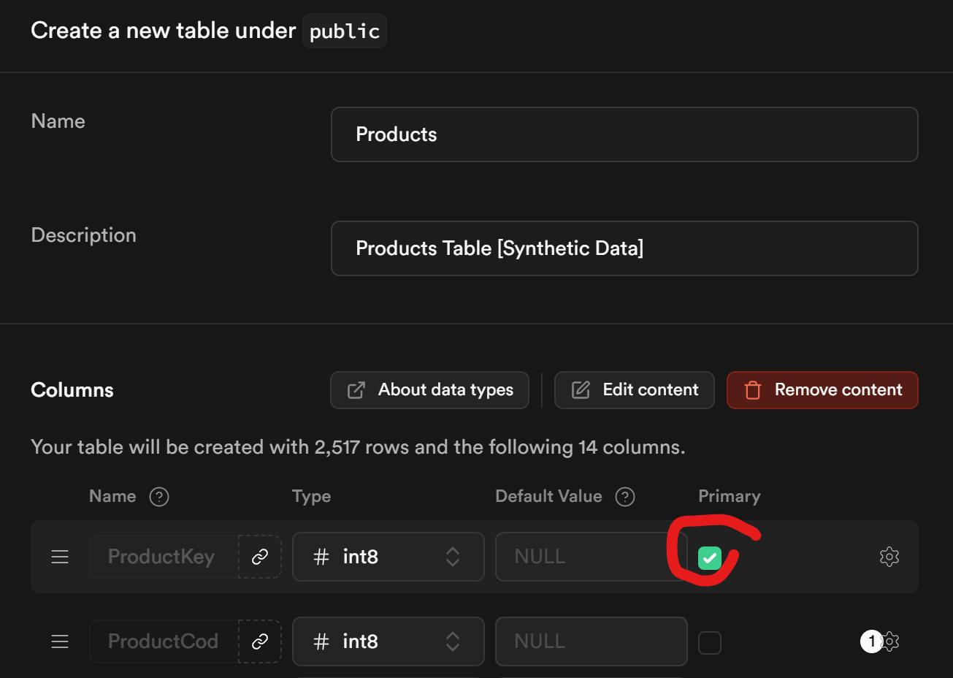

- Finally, add the ‘Sales’ table. For this one, also check the data types but do NOT select a primary key column. Doing so will cause errors.
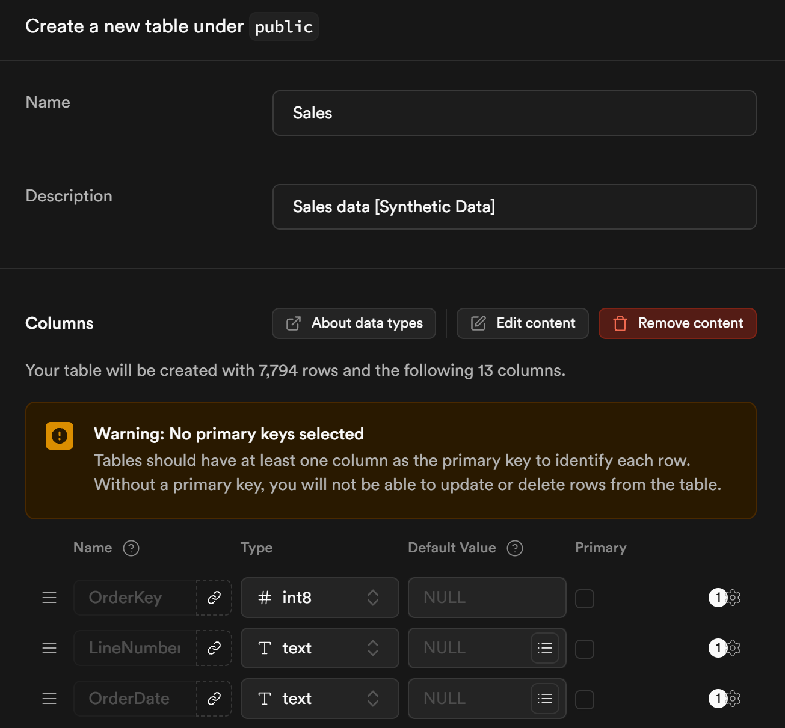

- At the end of this process, you should have three tables available - Customers, Products, and Sales. You can see them in the ‘Table Editor’ tab.
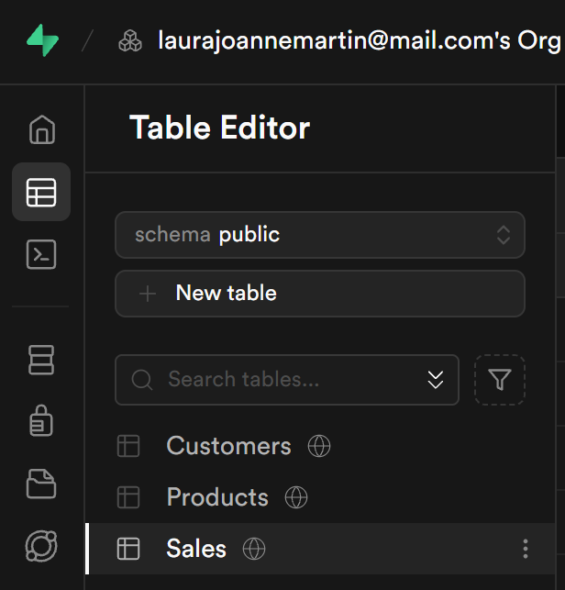

- To add the SQL queries we will be using in the sessions, you’ll need to create new SQL snippets under the ‘SQL editor’ tab and copy and paste in the text of all the .sql files in the GitHub repository for this session.
